

TERMS OF BUSINESS 2024 -2025

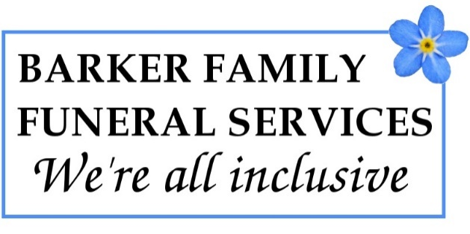
We adhere to the current code of practice of the National Association of Funeral Directors (NAFD), a copy of which is available upon request. We aim to act in a professional manner and provide a courteous, sensitive and dignified service to you.

DEFINITIONS
“The company” means Barker Family Funeral Services. The Street, Long Stratton NR15 2XJ
“We” mean the owner Craig Barker
“The client” means the person or persons contracting with the company for the provision of the service.
“The service” means the provision by the company, the services as set out overleaf.
ACCEPTANCE OF TERMS
All orders by the client for the service shall be subject to these Terms of Business to the exclusion of all other prior terms and all representations whether in writing or otherwise Estimates provided to the client are not binding unless and till accepted by the client by signature of the Estimate or arrangement sheet and confirmed in writing by the company.

OUR SERVICE STANDARDS

The National association of funeral Directors (NAFD) code of practice requires that we provide a high quality service in all aspects. If you have any question or concerns about the service we provide to you, please raise them in the first instance with our Funeral Directors. If that does not resolve the problem to your satisfaction, we have a robust complaints procedure which you can follow, and is freely available on our website.

We cannot be held responsible for the performance of any third parties which may include but is not limited to, crematoria, councils, grave diggers, ministers, civil celebrants, florists, printers, vehicle hire, newspapers, hospitals, doctors, coroners, registrars, international repatriation services providers.

PRICES

Certain items of the service are or may become subject to VAT at the prevailing rate at the date of the invoice. Where this is the case the company shall be entitled to charge the client such VAT. The company will act as agent for the client in respect of the disbursements and is authorised by the client to pay any such disbursements as they arise on behalf of and in the name of the client. The liability to pay the disbursements not settled by the company will remain with the client.


PAYMENT

Unless otherwise agreed in writing by the company, payment of the invoice is due no later than 14 days from the date of the invoice, or in full before the date of the service. A 50% deposit is required before any arrangements will be made on behalf of the client.

Fixed cost direct funerals must be paid in full before the funeral date will be booked, the funeral may not proceed if payment is not received, this is at the discretion of the funeral director. Cancellation charges will apply and will be added to the invoice.

The company will charge interest on the late payment of invoices at the rate of 5% above the base lending rate of HSBC Bank, from the due date for payment up to and including the date of actual payment.

Reminder Letters will be sent every 7 days via email and recorded delivery. An administrative charge of £20 per letter will be added, for each reminder letter sent. Should the invoice remain unpaid, with no contact at 30 days, it will be passed to a debt collection agency with any incurred costs added to the original invoice.

PROBATE

You do not need to wait for probate if sufficient funds are available, settlement can be made directly from the deceased’s bank account without waiting for probate.

DWP PAYMENTS FOR FUNERAL EXPENSES

Please inform us if you intend to claim for assistance for funeral expenses from the DWP. Generally these payments will not cover the entire cost of the funeral and there will be a balance to be paid. The rules for eligibility are complex and we suggest that you speak with your local DWP office for advice.

DATA PROTECTION AND GDPR 2018

We respect the confidential nature of the information given to us and where you provide us with personal or sensitive date, we will ensure that the data is held securely, in confidence and processed for the sole purpose of carrying out our services. In order to provide our service we may need to pass such data to third parties and those third parties, who are performing some of the services for you, may contact you directly. Under the Act you have the right to know what data we hold and you can, by applying in writing and paying a fee, receive copies of that data.

You are confirming that you have permission to give consent and to supply this information, including your relatives and friends that you specify.

COOLING OFF PERIOD

The cancellation of consumer contracts made in the consumers home or place of work etc Regulations 2008 may give you the right to terminate this agreement in the cooling-off period of 14 days. If you wish the performance of the agreement of which this right applies to commence before the end of the cooling off period, you must sign the authority on the arrangement form presented to you. In the event you exercise your right to cancel this contract during the cooling off period, you will be required to pay the costs incurred to the company for any goods and services purchased on your behalf.

TERMINATION

This agreement may also be terminated before the services are delivered: by us if you fail to honour your obligations under these Terms of Business and our Terms and Conditions. By you, communicating to us in writing, terminating your instructions.

If we or you terminate this contract, you will be required to pay the costs incurred to the company based upon the work which has been carried out and any goods and services already supplied at the time your termination is received.

